JIRA Tool – 3 Lecture

HPALM- 2 Lecture

Lecture I

JIRA introduction

Different model / methodology / process for SDLC

Water fall

V

Agile – 90/95%

Scrum

Sprint

Agile meetings

Different meetings

1. Grooming meeting – US- doubt clarity
2. Sprint planning meeting

Allocation – US 01 US 02 US 03 US 04

Estimation- Story point – 1 2 3 5 8 13 21 ……..

1. Daily stand up meeting – monitor work assign / work progress
2. Review meeting – demo conduct
3. Retrospective meeting – good & bad

JIRA tool introduction

What is JIRA?

* JIRA is nothing but project management tool
* JIRA is an issue tracking tool
* Defect tracking tool
* Bug tracking tool
* JIRA is a software tool that to manage project is an agile way

Why JIRA?

* JIRA is an all in one solution for multiple project

1. Creating backlog
2. Creating sprint
3. Creating task
4. Updating status on the board – to do in progress testing done
5. Managing releases
6. Managing workflow

JIRA tool different tab

1. Roadmap
2. Backlog
3. Active sprint
4. Issues
5. Reports
6. Component
7. Code
8. Release
9. Project settings

Agile

Scrum

Sprint – 2week

Sprint duration – 1 week / 2 week / 3 week / 4 week

Max sprint duration – 4 week

Min sprint duration- 1 week / Zero sprint

Sprint – US 01

Tester

TCD

Review

TCE

Defect lock/assign/raise

Test evidence

Url

Screenshots

Reproduce steps

Questions

1. Have you created any defect on JIRA?

Yes

1. Have you uploaded any test evidence?

Yes

1. Have you created any epic?

Product owner

1. Have you created any US?

Product owner

1. In your company you are working on which model?

Agile

1. Which agile framework / flavor / sub type/ type use in your company?

Scrum

1. In agile US are given in which from?

Description

Acceptance criteria

1. Who will allocate US?

SM/TL/PO

1. Where to allocate particular US?

Sprint planning meeting / JIRA board

1. What is JIRA?

PMT

DTT

BTT

1. Have you assign any defect to developer?

Yes

1. Who is responsible person to allocate the defect to developer?

Tester

1. Who is decide the priority & severity?

Initial – Tester – priority

Severity – tester

1. In JIRA testing point of view?

* Allocate US
* Create sub task
* Create defect – tracking till close defect
* Upload test evidence

1. How get build on JIRA?

Refer retesting Note point

Developer- comments – Url/test data/sceenshots/unit testing

1. Who is admin of the JIRA?

PO/SM

1. Who is responsible person to create project on JIRA?

PO

1. How to get JIRA access?

Daily standup – SM

Lecture 2

**How to get JIRA access? – PO/SM**

**How to create project?- PO**

**How to add users / peoples in JIRA?- PO**

**How to create backlog- epic?- PO**

**How to create stories in JIRA?- PO**

**How to link epic to US? – PO**

How to create version / release? – PO

How to link version/release to US?- PO

Sprint 1- 2 week – 1 release – also its depends on the organization – 2 sprint – 1 release

**Case Study/Project**

“Taj Hotel/” is looking for an **Online Home Delivery Service** for her Restaurant / Hotel

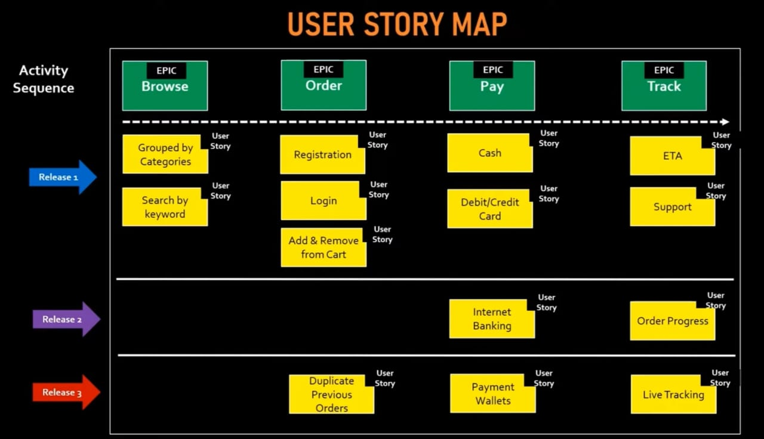

**Creation of Epic**

**Epic 1-** Browse & Search

Summary- Provide the ability for the customer to browse and search the food menu

**Epic 2-** Order

Summary- Provide the ability for the customer to order online

**Epic 3-** Payment for Online order

Summary- Provide the ability for the customer to make payment for their online order

**Epic 4-** Tracking for Online order

Summary- Provide the ability for the customer to tracking their order online

**Creation of User Stories**

**US-1**

Summary- Grouped by Categories

**Description Criteria**

**As a** customer

**I want** to view the food items arranged by categories

**So that** I can easily select the food items & order

**Acceptance Criteria**

**GIVEN** Customer is logged onto the online application

**WHEN** Customer are on the home page

**THEN** Customer should be able to see the food items grouped by categories

**Supporting Model / Functional Model**

1. **Refer to table below for the mapping between categories & food items**

|  |  |
| --- | --- |
| **Category** | **Food Item** |
| Breakfast | Item 1 |
| Breakfast | Item 2 |
| Lunch | Item 1 |
| Lunch | Item 2 |

1. **Refer to mockup attached for the navigation**

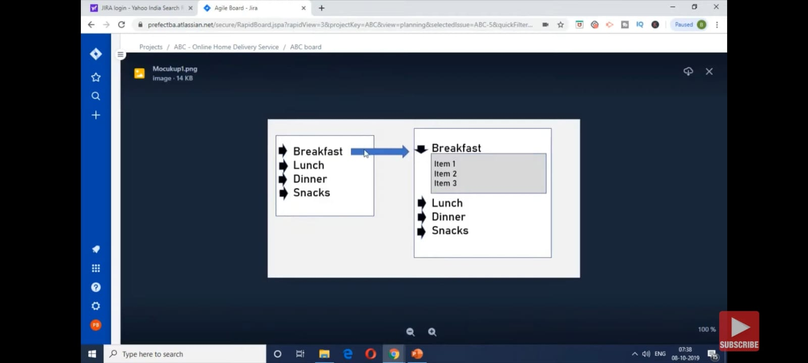

**US-2**

Search by keyword

**US-3**

Registration

**US-4**

Login

**US-5**

Add & Remove from Cart

**US-6**

Duplicate Previous Orders

**US-7**

Cash

**US-8**

Debit / Credit Card

**US-9**

Internet Banking

**US-10**

Payment Wallets

**US-11**

ETA

**US-12**

Support

**US-13**

Order Progress

**US-14**

Live Tracking

**Lecture 3**

Create sprint in JIRA? – PO

Adding user stories in current sprint in JIRA?- PO/SM

Sprint planning meetings?

Starting sprint in JIRA?- PO

Task creation for each and every US in story board / task board?- PO/ self

Creating the sub task for story? PO/self

Assign sub task to teams / self (PO/SM/TL)

Burn the hours in JIRA?

**Creating the bug?**

Daily standup meeting

Sprint review meeting

Retrospective meeting